Question A
[122 marks]

- Please explain the benefits of the pay-as-you-go feature of cloud computing.

[6 marks]

- What are the benefits of using software as a service from a cloud provider like AWS? Please provide an example.

[6 marks]

- Please explain the benefits of using AWS’s Elastic MapReduce service (EMR).

[6 marks]

- Please explain why automatic fault tolerance is so important for Big Data processing?

[7 marks]

- Please explain why MapReduce is designed for the scaling out deployment configuration rather than scaling up.
[6 marks]

- In the Hadoop MapReduce framework please explain what happens to the data as it is emitted from the mapper and arrives at the reducer. Also how does this help us achieve the output that we desire?
[8 marks]

- Please describe the benefits of using a combiner.
[6 marks]

- Please explain how the distributed cache feature of MapReduce can be used for the following two applications (diagrams are included to help you remember how these applications work) :

  - The replicated join.

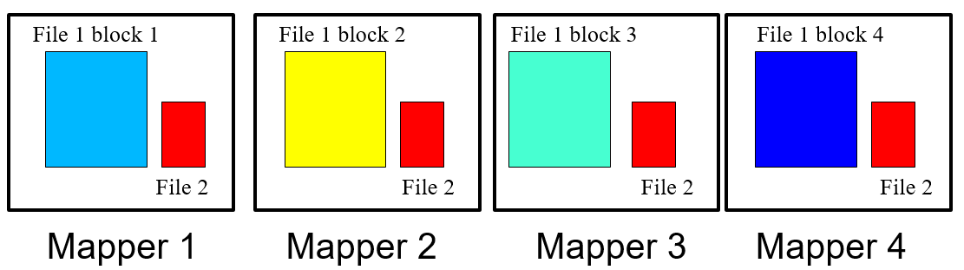

[4 marks]

  - Compressing a collection of document using a dictionary.

word | Code word
Banana | 001
Carrot | 002
… | …
… | …
Zukini | 102
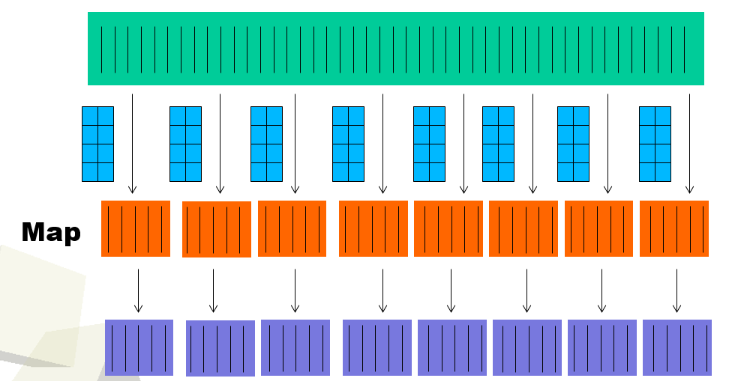

[4 marks]

- Please explain the differences between the partitioning and the bucketing features of Hive.

[6 marks]

- Describe the differences between application masters in YARN and the job tracker of the MapReduce 1 framework.

[8 marks]

- What is the major challenge in real time analytics involving big data? How can you address this challenge using the lambda architecture?

[8 marks]

- Please explain how the bulk synchronous process (BSP) computational model of Pregel works. Why does it work better than MapReduce for processing big graphs?

[8 marks]

- Please describe two features of Apache Spark that helps it process data faster than MapReduce.

[8 marks]

- Describe what is an RDD? What are the good properties of RDDs?

[7 marks]

- How does Apache Spark achieve fault tolerance?

[8 marks]

- Please explain the difference between the types of problems that NoSQL stores are designed to solve versus MapReduce.
[8 marks]

- Why is it challenging for NoSQL stores to achieve consistency? How do NoSQL stores address this challenge?
[8 marks]

Question B
[26 marks]
Answer the sub-questions of question B using the data described below.

Index | Column Name | Possible values
0 | Student ID | continuous
1 | Age | continuous
2 | Gender | Male, Female
3 | Phone number | continuous
4 | Campus | Bundoora, CBD, Bendigo
5 | Number of subjects | Continuous
6 | Grade point average | Continuous
7 | Email address | String

Here are a few Spark API calls that maybe useful for you. You do not need to use all these API calls in your answers. Also if you remember some other API calls which are not included here, feel free to use them in your answers.

def collect(): Array[T]

Return an array that contains all of the elements in this RDD.
def count(): Long

Return the number of elements in the RDD.
def distinct(): RDD[T]

Return a new RDD containing the distinct elements in this RDD.
def filter(f: (T) ⇒ Boolean): RDD[T]

Return a new RDD containing only the elements that satisfy a predicate.
def first(): T

Return the first element in this RDD.
def flatMap[U](f: (T) ⇒ TraversableOnce[U])(implicit arg0: ClassTag[U]): RDD[U]

Return a new RDD by first applying a function to all elements of this RDD, and then flattening the results.
def foreach(f: (T) ⇒ Unit): Unit

Applies a function f to all elements of this RDD.
def groupBy[K](f: (T) ⇒ K)(implicit kt: ClassTag[K]): RDD[(K, Iterable[T])]

Return an RDD of grouped items.
def map[U](f: (T) ⇒ U)(implicit arg0: ClassTag[U]): RDD[U]

Return a new RDD by applying a function to all elements of this RDD.
def mapPartitions[U](f: (Iterator[T]) ⇒ Iterator[U], preservesPartitioning: Boolean = false)(implicit arg0: ClassTag[U]): RDD[U]

Return a new RDD by applying a function to each partition of this RDD.
def reduce(f: (T, T) ⇒ T): T

Reduces the elements of this RDD using the specified commutative and associative binary operator.
def sortBy[K](f: (T) ⇒ K, ascending: Boolean = true, numPartitions: Int = this.partitions.size)(implicit ord: Ordering[K], ctag: ClassTag[K]): RDD[T]

Return this RDD sorted by the given key function.
def take(num: Int): Array[T]

Take the first num elements of the RDD.
def zip[U](other: RDD[U])(implicit arg0: ClassTag[U]): RDD[(T, U)]

Zips this RDD with another one, returning key-value pairs with the first element in each RDD, second element in each RDD, etc.
def GroupByKey(): RDD[(K, Iterable[V])]

Group the values for each key in the RDD into a single sequence.
def join[W](other: RDD[(K, W)]): RDD[(K, (V, W))]

Return an RDD containing all pairs of elements with matching keys in this and other.
def reduceByKey(func: (V, V) ⇒ V): RDD[(K, V)]

Merge the values for each key using an associative reduce function.

Also given the code below.

scala> val lines = sc.textFile(“students.txt”)
// assume all the columns are separated by “, ”
scala> val split_lines = lines.map(_.split(“, “))

Write spark code to do the following. Your solution can consist of one or more lines of Spark code. You do not need to make the output format look good.

- Output all lines of students whose grade point average was above 0.8 and is from the Bundoora campus.
[6 marks]

- Output the number of students who are male and study in the Bendigo campus.
[10 marks]

- Output the student ID and email address of the student who has the highest grade point average. If there is more than one student with the same highest grade point average just return any one of them. So you should always only return one student.
[10 marks]

Question C
[32 marks]
Suppose you are given the data that contains the first 7 columns of the file used for task 1 of your assignment. Shown below.

Attribute number | Attribute name | Description
1 | Age | Numeric
2 | Job | type of job (categorical: "admin.", "unknown", "unemployed", "management", "housemaid", "entrepreneur", "student",  “blue-collar", "self-employed", "retired", "technician", "services")
3 | Marital | marital status (categorical: "married", "divorced", "single"; note: "divorced" means divorced or widowed)
4 | education | (categorical: "unknown", "secondary", "primary", "tertiary")
5 | Default | has credit in default? (binary: "yes", "no")
6 | balance | average yearly balance, in euros (numeric)
7 | housing | has housing loan? (binary: "yes", "no")

Below you are given problems to solve using MapReduce. First, I will explain what I expect in your answer. You do not need to write actual Java code. Just high-level pseudo code is enough. Please specify what is inside the mapper and reducer in terms of the following three aspects:
- What is the input key and value
- What processing is performed by each map/reduce call
  - Include the emitting of the output key, value pairs.
- You may need to specify a cleanup method for some questions. In this case write what processing is done in the cleanup method and what is emitted.
Feel free to use more than one MapReduce phase if required.

Here is an example of what I mean by pseudo code, although of course it is not the answer to any of the questions ☺

Mapper
- Input Key: byte offset of input line, Input Value: input line
- Inside map function
  - Extract from the input line the balance.
  - Extract from the input line the age.
  - Emit (balance, age)

Reducer
- Input Key: balance, Input Values: set of age values
- Inside reduce function
  - For each age value
Emit (balance, age)

- You are asked to use MapReduce to report the number of people with job category student. Do not write a combiner or do local aggregation for your answer, since that is the next question. Don’t worry about the output format, as long as the correct count is outputted, that will be OK.

[8 marks]

- Can we use a combiner or local aggregation to reduce the amount of data shuffled for the previous question? If no why not. If yes then write the pseudo code for a combiner or local aggregator for the previous question. Write the combiner or local aggregator in the same format as the pseudo code example given earlier. Please explain how the combiner or local aggregator reduces the amount of data shuffled.

[6 marks]

- You are asked to use MapReduce to output the age of the oldest person for each job category. Do not write a combiner or do local aggregation for your answer, since that is the next question. So the output should look something like the following (don’t worry about trivial formatting things like whether the output will have “ “ around the words, etc.).

admin. 64
unknown 80
unemployed 70
management 65
…
[12 marks]

- Can we use a combiner or local aggregation to reduce the amount of data shuffled for the previous question? If no why not. If yes then write the pseudo code for a combiner or local aggregator for the previous question. Write the combiner or local aggregator in the same format as the pseudo code example given earlier. Please explain how the combiner or local aggregator reduces the amount of data shuffled.

[6 marks]

